***NEW ADVISING WEBSITE!***

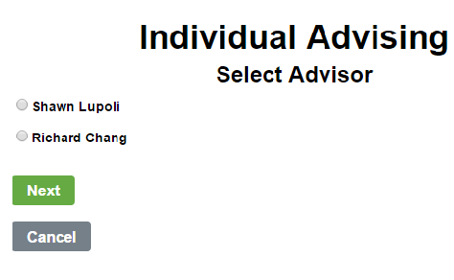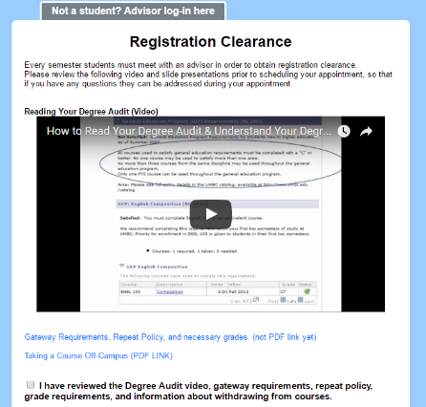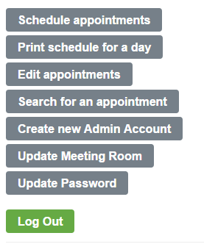This new website is an improved version of the website you all know and love (or hate)! It will give advisors the ability to schedule multiple appointments at one time and even allow you to assign specific students appointments without their needing to do anything!

Advisors will be able to change appointment times and remove unwanted appointments at a click of a button. When signing up, students must watch a quick video that explains how to prepare for the appointment.

Later when students sign up, they will be shown a list of all the different advisors with available times they could take instead of having to look through each day hopping that there was an appointment there already.

If something comes up and a student finds themselves unable to make their appointment they can reschedule it for another date! Find out more by looking at the website yourself at: <https://swe.umbc.edu/~schu1/CMSC331Project2/htdocs/registrationClearance.php>